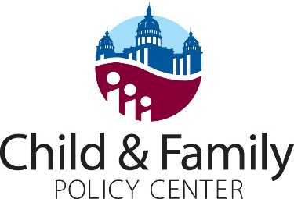

FACT SHEET
SSB 3158 is the wrong approach on SNAP

SNAP — called Food Assistance in Iowa — helps fill the gaps for workers with low wages and unsteady hours and helps workers weather tough periods in between jobs. When you’re able to cover a basic need like putting food on the table, you can get back on your feet more quickly.
SSB 3158 would make radical changes to our state's SNAP program. It includes a series of damaging proposals that would take away meals from parents, their children, people with disabilities, caregivers, and others struggling to make ends meet. It would add layers of red tape, require the state to build costly new reporting systems and limit the state’s options to respond to economic downturns.
Taking away access to basic food security will only multiply challenges facing low-income Iowans. The bill is fundamentally flawed, and no amount of tweaking can fix it.
It’s expensive and counterproductive
- The bill would institute new employment and training requirements and programs and force the state to create — and participants to comply with — complex new reporting systems to track compliance. In Tennessee, the state projected that administering similar SNAP workfare requirements would cost an additional $225 million every year.
- Whatever the stated goal, the main accomplishment of policies like this is punishing parents and others struggling to get by working low-paying positions, caregiving, or in between jobs. Research from other programs and states shows these requirements rarely lead to significant increases in employment. Instead, people whose benefits are cut often fall further into poverty.
It will set back working people on the verge of getting on their feet
- The bill would prohibit Iowa from using an option to adjust income cutoffs so that working families don’t abruptly lose their SNAP benefits when they earn slightly more than the federal maximum. Iowa currently uses the categorical eligibility option to raise the maximum level for SNAP from 130 percent of the federal poverty level, or about $28,200 per year for a family of three, to 160 percent of poverty, or about $34,800. The more a worker earns while they’re on SNAP, the smaller their benefits.
- By removing categorical eligibility, this bill would essentially reimpose a benefit cliff, causing thousands of working Iowa households to lose SNAP benefits just as they are getting back on their feet. In FY 2019, a monthly average of 9,230 Iowa households and 19,279 individuals got for food assistance under categorical eligibility. They received a monthly average benefit of about $47.
- Because children in these households would lose their SNAP benefits, they would also lose access to free school lunches and breakfasts.
It will reduce state flexibility
- SNAP is designed to be a first responder, to help people make it through economic downturns and natural disasters. The bill would ban the state from applying for a waiver of work requirements during such periods. Federal SNAP rules limit most working-age adults not raising children to three months of food assistance out of every 36 months unless they are working at least 20 hours a week or otherwise exempt. But states can seek temporary waivers from the time limit for higher-unemployment areas where it is harder to find a job.
- Since the late 1990s, Iowa has requested a waiver for only three years: 2011 through 2013, the aftermath of the Great Recession. Removing this option means Iowa would go into the next economic downturn or disaster with one hand tied behind our back — limiting the federal funds our state could receive, just when we need it the most.

Tennessee General Assembly Fiscal Review Committee, Fiscal Note Hb 110 – SB 550, March 26, 2019
Iowa Department of Human Services
https://www.cbpp.org/research/food-assistance/states-have-requested-waivers-from-snaps-time-limit-in-high-unemployment

