KEY ACTIVITIES FOR SUCCESS OF DSMES TELEHEALTH PROGRAMS SPELL
T.E.L.E.H.E.A.L.T.H. P.R.O.G.R.A.M.S.
Telehealth is quickly emerging as a promising new technology that is being widely accepted by both patients and providers. Although these individual activities are not in any particular order for implementation, they will provide you with all the key requirements to: get started; achieve success; and deliver effective and efficient DSMES telehealth services in your practice setting.
T | Tap into external resources for telehealth information and needed expertise, such as:  - Telehealth/telemedicine parity laws require private payers in a state to reimburse for telehealth services the same way they would for an in-person service)¹  - Telehealth Resource Guide (https://www.astho.org/Health-Systems-Transformation/Medicaid-and-Public-Health-Partnerships/Telehealth-Resource-Guide/)
E | Engage first with executive management² to:  - Obtain its approval of program (will typically require you to submit a written document that “builds the business case” for a DSMES telehealth program)  - Acquire commitment to furnish necessary resources to the program  - Establish:  - A long-term vision for the program  - Quality measures and goals for the program (i.e., clinical, patient and provider satisfaction, financial, etc.)  - Help mainstream the program into the standard care process
L | Learn the Medicare reimbursement rules (coverage guidelines) for DSMES/DSMT, and the additional telehealth rules for the original and distant sites. The web/online links below provide a summary of the detailed coverage guidelines:  - https://www.cms.gov/Regulations-and-Guidance/Guidance/Transmittals/2018Downloads/R4173CP.pdf  - https://www.nova.edu/health-compliance/forms/medicare-claims-processing-manual-chapter-12.pdf  - https://www.cms.gov/Regulations-and-Guidance/Guidance/Transmittals/2016-Transmittals-Items/R3586CP
E | Evaluate (assess) the DSMES telehealth needs of:  - Community People with diabetes (PWD)  - Employer groups  - Current PWD in your health care organization  - Providers (internal and external)  - Health care insurers in your area
H | Have a DSMES telehealth coordinator and an effective leader and champion
E | Evaluate and report all outcomes: patient, provider and program
A | Assure HIPAA compliance to the telehealth technology
L | Let executive management know (via hard data) how your telehealth program helps to meet  Health insurers’ value-based payment metrics; meeting the metrics is required to receive insurers’ extra/incentive reimbursement  - Telehealth services are an effective way to drive down care delivery costs, making them valuable tools to use in value-based reimbursement models that reward providers for lower utilization costs and improve quality.
T | Team up with your finance, accounting and revenue cycle departments to:  - Analyze program costs, estimated revenues and return on investment, and financial risks  - Establish the program’s operating budget  - Create a sustainable business model for the program  Team up your legal department to survey:  - The regulatory environment: your location/state requirements for licensure, credentialing, privileging, malpractice, security and privacy
H | Harness your telehealth program to improve and enhance your health care organization’s population health strategies:  - Telehealth technology is a significant enabler for population health initiatives  - Population health and telehealth programs complement one another across the entire continuum of care
P | Pursue reimbursement for your telehealth program from all health care insurers under contract with your health care organization.
R | Recruit a:  - DSMES Telehealth Program Design Team to plan and implement the program, and also to evaluate and revise policies and procedures in your business plan as needed  - Consider using project management strategies for the team’s activities  - Besides delivering on time and in budget, and scope, project management means much more. It unites teams, creates a vision for success and gets everyone on the same page of what’s needed to stay on track for success. When projects are managed properly, there’s a positive impact that reverberates beyond delivery of ‘the stuff’.  - The 10 key benefits of using project management techniques with the team are:  - Manages integration (assures strategic alliance) with the organization’s goals, processes, mission and vision  - Defines a plan and organizes chaos  - Projects are naturally chaotic. The primary business function of project management is organizing and planning projects to tame this chaos. A clear path mapped out from start to finish, along with action steps for each team member at each meeting (with deadline completion dates) ensures that the outcome meets the goals of your project  - Establishes a finite schedule for team meetings and the protocol for the meetings  - Enforces and encourages teamwork  - Assures clear and timely communication across the different organizations and departments involved in the project on all relevant matters  - Maximizes resources  - Controls costs  - Manages change…which itself is a complex and daunting task  - Manages quality  - Ensures knowledge is captured and optimized  - DSMES Telehealth Program Stakeholder Advisory Committee for periodic review of the program metrics and input
O | Outline a plan for adherence to the 10 National Standards of DSMES³ in your telehealth program
G | Garner the telehealth technology…and test, test, test before implementing with patients
R | Require “practice runs” (small pilots) before telehealth program is launched in full to identify problem areas and have the opportunity to fix
A | Acquire a data management plan for your telehealth program⁴. The data management plan may include specialized software
M | Market, market…and market some more to:  - Community people  - Community partners (e.g., local department of health, area agency on aging, etc.)  - Providers (internal and external)  - Internal organization employees  - Local employer groups  - Business coalitions (such as the local chamber of commerce)  - Network peers (e.g., Association of Diabetes Care and Education Specialists)
S | Sculpt for your DSMES telehealth program a business plan⁵ comprised of these 6 components:  - Key Preliminary Activities Plan  - Operations Plan  - Marketing Plan  - Financial Plan  - Clinical/Teaching Plan  - Continuous Quality Improvement Plan

Glossary

- Parity laws at the federal and state level are designed to require commercial health insurance plans to treat their subscribers and certain health conditions fairly. Thus a parity law in a state requires the plans to cover certain health benefits. Parity laws do not apply to all plans in the same way, and not all types of health insurance are covered by the Federal Parity Law or a state parity law.
- Executive management refers to a team of personnel who are responsible for the day-to-day management of the company. The team members are the president and chief executive officer (CEO) and other executives such as the vice president of accounting and the vice president of operations. Their responsibilities include the overall conduct of the business and all operational matters, organizational structure of the business as well as allocation of resources, determination and implementation of strategies and policies, goal setting and ensuring timely reporting and provision of information to the board of directors. Source: https://www.quora.com/What-is-executive-management.
- The National Standards of DSMES (2017, current edition as of 2020) are ten evidence-based guidelines for operating a DSMES program. They are updated every five years by an independent team of diabetes healthcare professionals. In order to bill Medicare for in-person or telehealth DSMES, a program must be accredited by the Association of Diabetes Care and Education Specialists or recognized by the American Diabetes Association. It is important to first check with all commercial/private healthcare plans that will be billed to determine if they cover DSMES as a payable benefit, and of so, if the plans require this quality designation.
- A data management plan consists of the use of a computer or online software program that allows DSMES program staff to document a variety of tasks and data. More comprehensive DSMES software will allow staff to:
  - Collect and track DSMES patients' behavior change goals, clinical indicators and medications
  - Administer online patient self-assessments and follow-ups
  - Track information about the educational services you provide
  - Generate reports on individual patient progress and your facility's progress
  - Manage classes and group education sessions
  - Create auto-populated, time-saving letters for referring physicians and patients
  - Gather data about your facility that is needed for your program accreditation
    - Software examples include: Microsoft Excel™ spreadsheet software (general software, but customizable; not designed specifically for DSMES applications); AADE7 System (DSMES program online, web-based data tracking program); and American Diabetes Association Chronicle Diabetes, a web-based stand-alone data tracking platform.
- Below is a brief overview of what each of these six plans that make up the DSMES Business Plan typically include:

Key Preliminary Activities Plan | 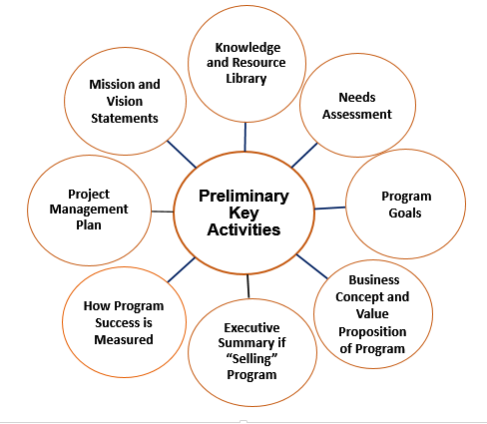
Operations Plan | 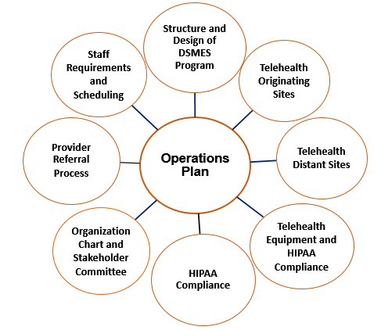
Marketing Plan | 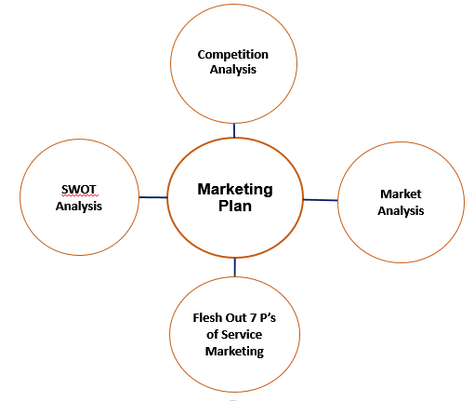
Financial Plan | 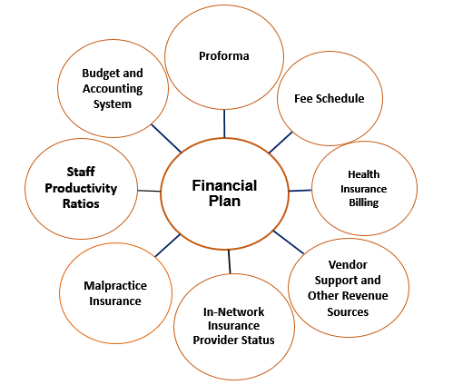
Clinical/Teaching Plan | 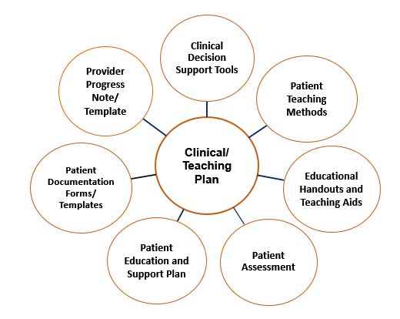
Continuous Quality Improvement Plan | 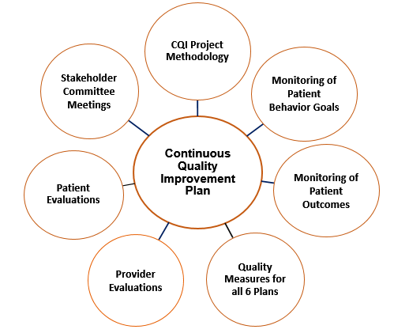

Mary Ann Hodorowicz, 3-24-20

