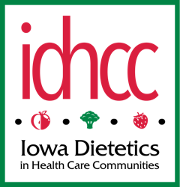 | Iowa Dietetics in Health Care Communities
Fall 2020 | Volume 10, Number 2
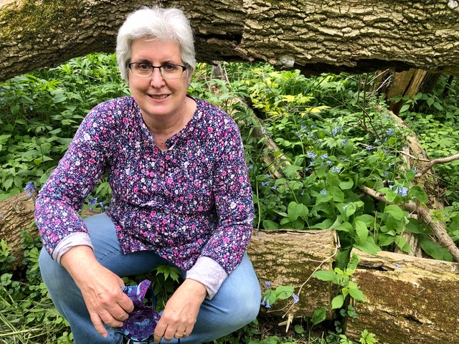  In This Issue:  From the Chair. . . . . . . . 1  Survey Results . . . . . . . .1  Lessons Learned . . . . . . 2  Successful Menu Development in Senior Living During a Pandemic 4  What Dietitians Need to Know About the Patient Driven Payment Model . . 5  Acronym Glossary. . . . . . 7  Meet the Board and Council . . . . . . . . . . . . . . . . . . .8  IAND 2020 Annual Virtual Meeting: Fresh Perspectives Ahead . . . 10  IC-HCC/Iowa ANFP Spring Conference . . . . . . . . . .10  Minutes from IDHCC Meeting . . . . . . . . . . . 11      Lessons Learned:  Pandemic Menu Planning  Food Safety & Sanitation Training  Non-Communal Dining Methods  Maintaining Nutrition and Hydration  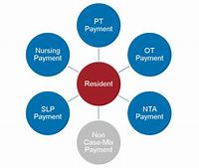  What Dietitians Need to Know About the Patient Driven Payment Model:  Payment Based on Component Score  Determining Case-Mix Group for NTA Component  Your Impact on Component Scores      Glossary of Acronyms:  Common LTC Acronyms Defined  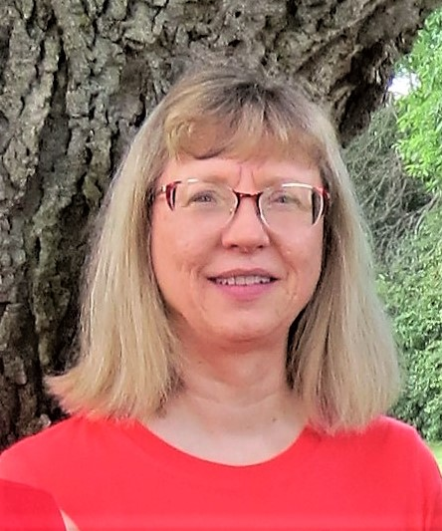  Kristen Simon-Frank, RDN, LD  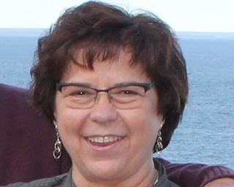  Sandy Goree, RD, CD, LD, CFE    Jocelyn Evans, RD, LD    Anne Sposato, MS, RD, LD, CCC  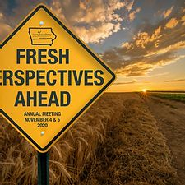  IAND 2020 Annual Virtual Meeting: Fresh Perspective Ahead  First Virtual Meeting  4 November 2020  Early Registration ends 1 November 2020 | From the Chair…  By Deb Edwards, MS, RDN, LD  dledwards702@gmail.com  I hope that you all had a good summer and were able to take time to enjoy friends and family. My heart goes out to those of you with loved ones in nursing homes, those with family members having to work in high risk situations and those of you who may have been affected by the derecho. It’s been a summer that we will always remember.  As I continue to work remotely for one nursing home and in person in the other I think about how dietitians are “essential workers” in health care. We work with our dietary managers and staff in our facilities to maintain high levels of sanitation to protect our residents against COVID and food borne illnesses. Our assessments and interventions are essential in keeping our residents in the best possible nutritional status to fight infections should they occur. We also play an essential role in providing educational resources to our dietary managers to make decisions in our absence. We need to be in contact with and work collaboratively with our all our nursing home colleagues by whatever means necessary.  With the recent changes in CMS guidelines and reimbursement we have a new opportunity to help our facilities receive reimbursement for Medicare patients by properly documenting residents who are malnourished and at risk of malnourishment. Please see Kristen Simon-Frank’s article on Patient Driven Payment System in this issue.  Thank you to those of you who replied to our recent survey:  https://www.surveymonkey.com/results/SM-73WDPTF37/  We appreciate your suggestions and will definitely incorporate them for future newsletters. It was gratifying to see that the three major reasons that you want to be a part of IDHCC include the annual conference, connecting with other RDs and the newsletter. One suggestion was to include profiles of members in each newsletter to help us get to know each other better. In this issue we asked the board members to introduce themselves and in future issues we’d like to introduce you! If you would like to send in a short personal bio please let us know. Otherwise we’ll contact you.  Kristen Simon Frank is also working with IAND to compile a list of RDs in IDHCC for better communication between us and recently sent out a request for your phone number. It would be also helpful to know what county you live in. This list would only be available to other RDs in IDHCC but I think it could really help with networking. Please let us know if don’t want to be included in this list or  would prefer your phone number not be used.  I am excited to let you know that Kathleen Neidert and Andrea Maher will be planning a “How To Consult’ workshop for RDs, probably as a virtual meeting hopefully early next year. This event will be offered in addition to our annual meeting. You will receive an invitation when we have a date. We will be learning from the best.  Experts predict that it could be a hard winter with COVID, but we can still live with gratitude, purpose, and resilience looking forward to good times too. I am looking forward to fall colors and hikes along the Mississippi. My fellow board members say they are looking forward to the IAND meeting and recognition of a colleague, getting back into their facilities, a potential COVID vaccine and the holidays through the eyes of her children. What are you looking forward to?  DO YOU: -  - Want a new and exciting experience ?  - Want to develop leadership skills and earn CPE credit for your leadership?  - Enjoy sharing ideas with other RDs?  - Want to attend the IDHCC annual conference for free?  - Want to help shape your profession?  - All of the above.  If you answered YES to the above we want you to lead us as CHAIR of IDHCC next year! We’d love to have you join us! Please contact any of the board members for more information.  Lessons Learned  By Gretchen L. Robinson, RND, LD  Marketing Dietitian, Martin Bros. Distributing  grobinson@martinbros.com  How do you plan for the unknown? With the novel coronavirus, there were so many unknowns. Senior living communities were “shut down” very quickly, leaving many of us with a lot of questions on how to provide meals and basic care to our residents.  How accurate was your previously written disaster plan? Many of us have never even been through a pandemic, so while creating policies and action plans, we might as well have been writing a fictional story. As the saying goes, hindsight is 20/20 and if you have not re-evaluated your plan, now is the time to do it! If you were fortunate enough not to have COVID-19 enter your building, now is  the time to consider lessons to be learned from others.  This pandemic was far-reaching, not only in terms of people impacted, but also the depth of services impacted. We quickly learned that our customers needed help, particularly in these four areas: pandemic menu planning, food safety & sanitation training/resources, non-communal dining methods, and creative ways to maintain nutrition and hydration status.  Pandemic Menu Planning – This means something to each community based upon the personnel available, storage capacity, etc. While trying to keep meals as close to “normal” as possible, for as long as possible, everyone needed to face the possibility of functioning without enough dining staff to serve meals and come up with a pandemic menu. For some, this meant a completely shelf-  stable menu, for others, a limited-staff menu that was easy to execute and included some flexibility. On the limited-staff type menu, more heat and serve options were utilized so that “anyone could do it” because limited staff  could also mean non-foodservice staff. Flexibility was built into menus to allow for use of product on hand or available from vendors. For example, “Hawaiian Pizza” was changed to “Pizza” or “Baked Potato” was changed to “Potato of the Day”. Therapeutic diets were approached more liberally, but still took modified textures into consideration. We were reminded by our non-foodservice staff just how strange some of our terminology was: “spoodle”, “hotel pan”, “#8 scoops”, etc. Non-foodservice workers have no idea what a “#8 scoop” means, so cheat sheets were made for service lines and storage. Many creative measures were taken to setup meal service with success, especially if low on staff or utilizing staff from other departments.  Food Safety & Sanitation Training – This pandemic has taught us the importance of cross-training and possibly provided new enthusiasm for providing food safety and sanitation to all-staff in-services. It’s easy to roll our eyes when something feels like a waste of our time but learning how to provide food safely is not wasting anyone’s time. Here are some things to consider:  - Make sure you have a Person-in-Charge trained and consider a plan if the PIC was not able to be in the kitchen; who else needs to be trained?  - There are many free or inexpensive food handler training courses that provide basic food safety skills for entry positions; consider having everyone take this training.  - Do you have posters displayed in the kitchen and break rooms that remind employees of proper procedures? A couple posters worth mentioning would be proper hand washing techniques, end cooking temperatures, cooler storage (no raw foods above cooked foods).  - If your regularly scheduled cooks were not able to make it into the building, would anyone know how to operate the stove and ovens? Do you have a manual or quick operating guide that can be easily located?  - When not in pandemic mode, consider providing five-minute trainings, or huddles on how to operate pieces of equipment for all of your kitchen/dining staff. This will help employees not be intimidated about using larger pieces of equipment.  - Do you have a checklist of tasks that need to be done each day and is it simple to understand? Do you have a binder or one central location where all your temperatures are taken? Do your forms indicate what temperature is within normal limits and what to do if the temperature is outside that range?  Non-Communal Dining Methods – This seemed to be one of the most common questions we received, “How am I going to feed the residents?” Believe it or not, there were locations that were large enough to continue to  serve out of their main dining locations because of the large area allowing for six feet of social distance. Other locations had to get crafty! We saw pictures posted on social media of residents eating in their doorways with fashionable “tv-trays” so they were still able to see other people and remain somewhat social. Mealtimes were staggered or reservations taken in order to limit the number in the dining room. The debate about porcelain over paper arose and  concerns over depleted or allocated paper supplies if started too early in the pandemic. For those folks who had to stay in their rooms for meals, a positive approach was taken: who wouldn’t want “Breakfast in Bed” or Hospitality Cart  offerings? Of course, non-communal dining brought up the challenge about residents needing assistance to dine and how that would be handled.  Maintaining Nutrition & Hydration – As residents became ill, appetites and thirst levels were greatly suppressed. To make matters more challenging, this was a long-lasting illness; flavor fatigue set in. Boredom isolation may have been a contributing factor for some as well. Residents grew tired of chicken broth after a couple days, but still needed food and fluids for several more days, if not weeks! We helped customers create high calorie, high protein meals and especially snacks. Foodservice carts were fashioned into a “Smoothie Bar on Wheels” or “Ice Cream” truck. Slushies were reinvigorated and the nostalgic Root Beer Floats and Purple Cows made a reappearance.  There is no doubt this pandemic stretched your entire staff to points of breaking. There are lessons to be learned here, both personal and professional. You probably learned about your own limitations and when to reach out for help. You do not have to do it alone; we can lean on each other and learn from each other during these unprecedented times.  Gretchen is one of eight Registered Dietitians at Martin Bros. Distributing. To share the lessons you have learned or to discuss this article in more detail, please contact the Martin Bros Dietitians at 800-847-2404.  What Dietitians Need to Know About the Patient Driven Payment Model  By Kristen Simon-Frank, RDN, LD  kdsimon-frank@hotmail.com  Medicare is now using the Patient Driven Payment Model (PDPM) to determine the payments made to skilled nursing facilities for Medicare Part A admissions. The payment will not be based on volume of service (as under RUG-IV), but  value of service; the cost of providing services to meet each resident’s unique needs and goals. What does that mean for dietitians?  Dietitians can: support effective nutritional care  focus time and resources for residents with greatest need  maximize the payment received for that care  enhance their job security  PDPM reflects more individualized payment for services while reducing administrative burden with only two required assessments; 5 day and discharge.  Payment Based on Component Scores:  PDPM uses five case-mix components: Physical Therapy, Occupational Therapy, Speech Language Pathology, Nursing, and Non-Therapy Ancillary Services, including Nutrition. Each component is further broken down into case-mix groups. Residents are classified into one group for each component, based on their MDS. Non-Therapy Ancillary Services has 6 groups. Each group is assigned a case mix index number. Medicare uses a Base Rate x Case Mix Index = Reimbursement for that component. Adding the five case-mix components plus a non-case-mix component (which does not vary between residents) creates that individual resident’s per diem rate.  Determining Case-Mix Group for NTA Component:  PDPM uses a list of 50 co-morbidities to determine the case-mix group. Each co-morbidity has a score based on the cost of providing services to manage that  condition. Adding up a resident’s co-morbidity scores determines which case-mix group they fall into. The more extensive the service required, the higher the score. The higher the score, the greater the payment. Nutrition-related NTA co-morbidities include Parenteral IV Feeding: Level High (which scores 7 points), Parenteral IV Feeding: Level Low (3 points), Diabetes Mellitus (2 points), Stage 4 Pressure Ulcer (1 point), Ostomy (1 point), Morbid Obesity (1  point) and Malnutrition (1 point.) These diagnoses must be current and made by a physician.  Your Impact on Component Scores:  MDS Section I 5600 Malnutrition (protein or calorie) or is “at risk” for malnutrition. Dietitians support this “at risk” diagnosis by using a validated malnutrition screening tool with a scoring matrix (such as Malnutrition Screening Tool, Malnutrition Universal Screening Tool or Mini Nutritional Assessment) on admission and following up with a full assessment. Know the 6 criteria for malnutrition: decrease in energy intake, weight loss, reduced hand-grip strength, loss of muscle mass, loss of fat, presence of edema. Nutrition Focused Physical Exams provide further documentation data to support the diagnosis and indicate the severity.  Communicate with providers when your malnutrition screening and assessment indicate a resident is at risk or already malnourished and this has not been  formally diagnosed with an ICD-10 code. Malnutrition ICD-10 codes include E43, E44 and E46. Prompt communication along the lines of “We feel this resident could be at risk for malnutrition; would you review documentation and consider a diagnosis” is appropriate. To get PDPM reimbursement, this diagnosis must be within the first 8 days of resident stay.  MDS Section I 8000 Morbid Obesity. Before PDPM, the nutrition-related diagnosis of Morbid Obesity was not possible to code on the MDS. Now dietitians can take an active part in capturing the dollars for reimbursement. Morbid Obesity (ICD-10 code E66) is defined as a BMI > 40. An alternate  definition of morbid obesity may be considered for use in the future: BMI > 35 plus a related health condition such as high blood pressure, sleep apnea, high cholesterol, GERD, T2DM, or osteoarthritis.  Speech Language Pathology case-mix index is higher when a swallowing disorder or mechanically altered diet is found documented in the resident chart and captured on the MDS. You can learn more about PDPM by visiting the CMS website, reading the MNT Provider (a resource published by the Academy of Nutrition and Dietetics), or watching an informative webinar titled “PDPM for Prevention and Management of Malnutrition” presented by Brenda Richardson, MA RDN LD CD LTC and posted by Martin Brothers webinar on demand.  Overview of PDPM  www.cms.gov/Medicare/Medicare-Fee-for-Service-Payment/SNPPS/PDPM.html  Frequently Asked Questions  www.cms.gov/Medicare/Medicare-Fee-for-Service-Payment/SNPPPS/Downloads/PDPM-FAQ_FAQ_Final_v5.zip  NTA co-morbidity score sheet  www.cms.gov/Medicare/Medicare-Fee-for-Service-Payment/SNFPPS/Downloads/PDPM_Fact_Sheet_NTAComorbidityScoring_v2_508.pdf  ICD-10 Codes  https://www.icd10data.com/ICD10CM/Codes  See Winter 2019 IDHCC newsletter for more resources on NFPE  PDPM payment for a single SNF resident for 100 day stay  If no NTA ancillary component is present  First 3 days @ $168.59/day x 0.72 CMI x 3 days = $364.  Additional 97 days @ $56.20 x 0.72 CMI x 97 days = $3,925.91  Total Payment: $4,289.16  If malnutrition* is diagnosed as the only NTA ancillary component  First 3 days @ $224.78/day x 0.96 CMI x 3 days $647.37  Additional 97 days @ $74.93 x 0.96 CMI x 97 days + $6,977.48  Total Payment: $7,624.86  $7,624.86 - $4,286.16 = Additional $3,335.69 over 100 days  (*documentation must support the diagnosis)  © 2019, Academy of Nutrition and Dietetics. REPRINTED from the MNT Provider, September/October 2019, Volume 18, Number 5/6 with permission.  Glossary of Acronyms:  CMS – Centers for Medicare and Medicaid Services  RAI – Resident Assessment Tool  PDPM – Patient Driven Payment Model, effective October 1, 2019  QAPI – Quality and Performance Improvement  IPA – Interim Payment Assessment  NTAS – Non-Therapy Ancillary Services  SNF PPS – Skilled Nursing Facility Perspective Payment System  ICD-10 codes – International Classification of Diseases- assigns a code to a diagnosis and what procedures are associated with that diagnosis  MDS – Minimum Data Set  MNA – Mini Nutritional Assessment Tool  MST – Malnutrition Screening Tool  MUST – Malnutrition Universal Screening Tool  GLIM – Global Leadership Initiative on Malnutrition  BMI – Body Mass Index  BIM – Brief Interview for Mental Status  RUG – Resource Utilization Group  ARD – Assessment Reference Day  CMI – Case Mix Index  CMG – Case Mix Group  CPS – Cognitive Performance Scale  OBRA - Omnibus Budget Reconciliation Act (also known and the Nursing Home  Reform Act of 1987)  Meet the Board and Council  Secretary:  I am beginning my second year as Secretary for IDHCC. I was a real newbie in IDHCC, but serving on the Board has introduced me to a group of wonderful, smart women; I encourage everyone to try it!  I have always worked on Long Term Care. My first full-time position was Director of Dietary for a 156 bed facility where I did clinical care and managed a staff of 25. I took time off when my sons Anders and Hans were born, and then gradually added consulting jobs over the years. Currently, I consult for Oelwein Care Center and Strawberry Point Lutheran Home. I am also part-time at Regional Medical Center in Manchester doing in-patient care and out-patient education. I still drive back and forth to Manchester but my care center work is done remotely at this time.  My husband Dennis and I are originally from Minnesota and we enjoy going “Up North” to see family and hike in the state parks. Dennis is pastor at St. Paul Lutheran Church in Maynard. As a congregation, we are working through how to do worship and Sunday School and fellowship in the time of CoVid. For fun, I read, sew and collect vintage paper dolls.  Treasurer:  I am Sandra Z. Goree, a 30 year consultant dietitian who contracts six acute care and rehab facilities, and on occasional relief for the local hospital. Since living neat the Mississippi River, my facilities are located in both Iowa and Wisconsin.  My primary education started long ago at University of Wisconsin Lacrosse and Stout; and continued at Colorado State University, Fort Collins, Colorado and Metropolitan State College, Denver, Colorado. My previous treasurer experience have been with church, fund raising our children to Germany and People to People Ambassador program, mission trips, and women’s retreats.  My designation for Iowa affiliation began nearly 30 years ago with UIDDA: Anne Blocker, and Theresa Eberhardt offered to train me as a consultant. I LOVED it and found my niche. I have now been consulting for 27 years. I stay active in IDHCC, IDA, and have been past president of UIDDA.  My husband and I live on a “Farmette” in rural Prairie du Chien, Wisconsin. We have two dogs, two cats, and a horse. We are caring for my niece’s dog Maya for the next three years while they work abroad in Papua, New Guinea. John and I are active in our church, hold small group bible studies in our home, and assist with missions/ministries. John and I have raised two children to adulthood: a daughter in human resources for Dupaco, who married a teacher – no children yet? And a son former navy working for Cabela’s in Prairie du Chien.  It is my honor to serve you as your treasurer of IDHCC. I have agreed to serve two terms due to the COVID-19 pandemic.  Past Chair:  Jocelyn received her Bachelor of Science Degree in nutrition and dietetics from Iowa State University in 2014 and completed her dietetic internship at the Mercy Weight Loss and Nutrition Center in 2015. She had a 2 week stint of long  term consulting during her internship where she realized her passion for the older adult population. She is a member of the Academy of Nutrition and Dietetics and Iowa Academy of Nutrition and Dietetics. Jocelyn started her career as a registered dietitian for Hy-Vee in Boone, IA in 2015. Currently, she runs her own consulting business working with multiple long term care facilities, the Iowa Department on Aging, and the Iowa Department of Public Health.  Jocelyn currently lives on a family farm in Huxley, IA with her husband, Jim and their 2 kids: A three year old daughter, Julia and 18 month old son, Jameson. Jocelyn grew up  in Marshall, MN and graduated from high school there. She started her degree in Iowa City at University of Iowa and then transferred to Iowa State University where she finished her Bachelor's Degree in Dietetics.  Her hobbies include running, reading, hunting, fishing, and spending time with her family. Her passion lies in gerontological nutrition and working to improve the lives of older adults both in care facilities and in the community. She is also passionate about mentoring and teaching younger dietitians. She loves this group and networking with other dietitians in this field.  Newsletter Editor:  Anne received her Bachelor of Science degree in Nutrition and Foodservice Management from the University of Nebraska - Lincoln and her Master’s degree and internship from Texas Tech University in Lubbock, Tx. Upon completing her education she joined the United States Navy where she served at the Naval Medical Centers in Jacksonville North Carolina, and Portsmouth, VA .  After her military service, Anne took a new path and attended culinary school in Portland Oregon. Returning to Nebraska she worked in restaurants for several years until she accepted a job as Production Manager with Sodexo in Cedar Rapids IA. Following this position she worked at Iowa City Rehabilitation and dietary supervisor and as a consultant and then as a dietitian at Washington County Hospital and Clinics. She now works part-time at the Iowa City Veterans Administration (Coralville) as an outpatient dietitian and consults with area nursing homes.  Anne lives in with her husband in North Liberty. She enjoys bicycling, traveling and cross-stitching. She is also a landlord for three properties in Johnson County. Her newest avocation is as a mentor for the newly formed Toastmaster Club at the VA Medical Center, sharing her 28 years of experience. Anne enjoys the creativity of her position as newsletter editor of IDHCC.  IAND 2020 Annual Virtual Meeting:  Fresh Perspectives Ahead  IAND Annual Virtual Meeting is 4 November 2020 from 0800 – 1700. The cost is $105.00 for the one day meeting. Early registration ends on 1 November 2020 on-line registration is at www.eatrightiowa.org  Topics Include:  No…Before Yes: The Debilitating Power of Perfection and Getting Out of Your Own Way  Genetic Testing for Personalized Nutrition: Where are We at?  Simplified Diet Manual – Let’s Plan the Meal!  One Size Doesn’t Fit All: Transforming Health to Achieve Excellence  Believing Children are Our Future: Serving Equity & Impartiality with Child Meals  Advance Your Communication Skills through Podcasting  What’s the New “Normal” in Our Quest for Food? Creating the Future from Lessons Learned  COMING THIS SPRING  COMBINED MEETING  IDHCC/IOWA ANFP Spring Conference  At Hilton Garden Inn  In West Des Moines, IA
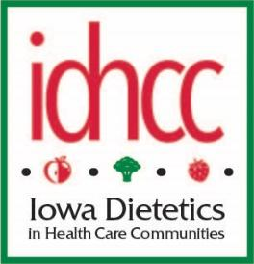
IDHCC Zoom Board Meeting

August 23, 2020

Present: Deb Edwards, Kristen Simon-Frank, Anne Sposato, Stephanie Labenz,
Sandy Goree, Monica Lursen (Executive Dir of IAND)

Deb called the meeting to order.
Secretary’s minutes approved as written.

September 2020 Newsletter:
One article about CoVid written by Martin Brothers dietitian has been submitted
Bios of all board members will be included in an effort to keep entire membership acquainted and included.

Deadline to submit bios to Anne is September 6.
Article on PDPM to be written—RDNs can be pro-active in assessing for malnutrition
Update on November IAND- speaker topics, registration opens 9/1/2020
Results of recent IDHCC survey. 28 respondents. Winner of $25 gift card was Dorothy McClure

Spring 2021 IDHCC meeting- Andrea Maher has begun work contacting hotel to book date.

“How to Consult” webinar plans- anticipate holding in January or February. Monica Lursen, along with Josh (IT) will help with technical set up. Will know more about projected cost after IAND in November.

Suggested topics: legal issues, contracts, setting up an LLC, what to expect during a survey, sanitation, resources, coding Section K.

Nominations: membership list needs to be accessible to other members and especially nominations committee. Discussion to have Josh add it to IDHCC on the Eatright Iowa website. Will include email addresses. Question should phone numbers be included. Stephanie Johnson may be a good resource for new nominations Stephanie Labenz to contact about job responsibilities.

Monica L. can share some contact information for IAND members if we have a specific request, but not the entire IAND member list.

Treasurer’s report: $10, 341.58 in checking and $12,664.69 in savings.



Anne Sposato, MS, RD, LD, CCC
940 Black Bear Bend
North Liberty, IA 52317

Iowa Dietetics in Health Care Communities (ID-HCC)
Executive Committee and Officers 2020-2021

Chair Nominations Chair
Deb Edwards, MS, RDN, LD Mogan Pavon, RD, LD
dledwards702@gmail.com morganpavon018@gmail.com

Chair-Elect Nominating Chair-Elect
Stephanie Labenz
idhcc.chairelect@gmail.com labenzdiet@gmail.com

Past Chair Past Nominating Chair
Jocelyn Evans, RDN, LD, Stephanie Johnson, RDN, LD
jocelynpohl28@gmail.com stephanie@sunsetconsultingrd.com

Secretary Newsletter Editor
Kristen Simon-Frank, RDN, LD Anne Sposato, MS, RD, LD, CCC
kdsimon-frank@hotmail.com jabs9@msn.com

Sandy Gore, MS, RD, LD Meeting Planning
Treasurer Andrea Maher, RD, LD
sandy.goree410@gmail.com andrea.maher@ivh.state.ia.is

Legislative
Kathleen Niedert, PhD, RD, CSG, LD
kniedert@aol.com

