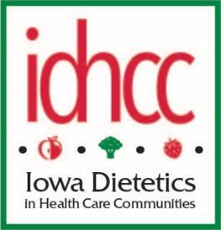
IDHCC Meeting – Transitional Meeting
Zoom
6.1.23

Present:
Stephanie Labenz, Kathleen Niedert, Andrea Maher, Jocelyn Evans, Becca Van Roekel and Julie Halfpop (minutes taken by Julie in Gretchen’s absence).
- Andrea offered an update on the annual meeting. She will send report.
  - Suggest to continue a registration cut-off as it motivated registration
  - Suggest selecting date soon. Favorable responses with DMACC
  - May consider raising the registration fee
  - Andrea will mentor Becca as the new Meeting Planner
    - Reminded of $500 stipend to research meeting features/speakers
- Jocelyn reported that we have a new Newsletter Editor, Megan Warnke who will research program options and make recommendation moving forward
- Julie will send thank you to Ann Sposato for her years of dedication as the newsletter editor
- We received summation from Chapt 58 revisions. Kathleen will summarize and have Gretchen send out to members (effective May 23)
- With the diet order writing privileges in the new revisions discussion hosted around hosting webinar or panel discussion on this topic
- Kathleen asked group to consider donation to the Foundation to support dietetic students. Julie suggested $1000. No quorum so no vote, table to next meeting
- Kathleen also encouraged group to consider a laddered CD to maximize interest for part of our funds vs CD with little return
- Board transition:
  - Share Google docs with new board members
  - Julie will let Josh with IAND know to update website officers
  - Thank you to Stephanie Labenz for her commitment to the group

Respectfully submitted
Gretchen L. Robinson, RDN, LD
ID-HCC Secretary

