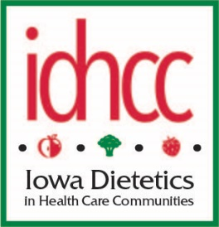
ID-HCC Spring Business Meeting
Hilton Garden Inn – West Des Moines
April 6, 2018

- Call to Order at 7:48 am
- Minutes:
  - Motion to approve past minutes. 2nd, motion passed.
- Treasurer Report: Motion to approve, 2nd, motion passed
  - Savings: $12,615.70; Checking: $25, 630.61
  - Income: $13, 421.38; Expenses $6,654.46 (part of income from DMACC payment)
- IAND Relationship
  - IRS status: The application is being reviewed and awaiting reply from IRS. Description of what the IRS was needing for a 501.6C compliance.
  - IDHCC has decided to stay external from IAND.
- Nominations/Elections
  - Review applicants and procedure for business meeting
    - Chair: Andrea Maher
    - Chair Elect: Jocelyn Evans
    - Treasurer: Sandy Zable Goree
    - Nominating Committee: Stephanie Johnson
No nominations from the floor. Simply majority vote per the bylaws. The candidate slate as presented for next Board/Council starting June 2018.
- Membership
  - Online vs paper
    - Decision was made for this to be the last year offering paper renewals to move toward Eventbright.
  - Eventbrite benefits
    - Twice a month deposits
    - Ability to send out mass emails, reminders to members
    - Lessens human error on entering information into an excel spreadsheet
  - Pay at conference by check
  - Membership Gift: Sanitation DVD made only for IDHCC members
- Grant/Awards
  - IDHCC Membership Award
    - Kristen Siemen Frank for a free membership for the year.
  - No other submissions
- Other Business
  - IA-ANFP joint ventures
    - IDHCC is very well known across the U.S. on our efforts to collaborate with one another along with staying current and ahead of the trends in Food & Nutrition.
    - Tossing around the idea for doing a dual meeting with IANFP in the Spring. Email Char on any comments with idea of doing a dual meeting.
- Adjourn 8:06 AM
Respectfully submitted
Amy Mooney-Geels, RDN, LD, CDM
ID-HCC Secretary

